Planning a game - Solution

Task . Decomposition - Break down the problem

**Player Actions**

| **Move** | **Item** | **Spell** |
| --- | --- | --- |
| Forward | Pickup | Cast |
| Turn left | Use | Learn |
| Turn right | Drop |  |

Task . Abstraction - Remove the unnecessary information

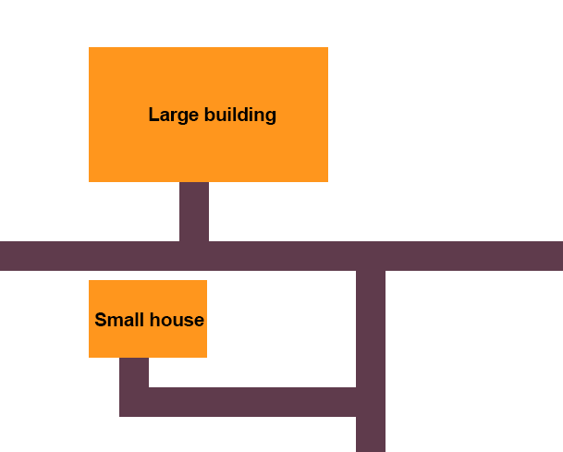

Task . Algorithmic thinking - Organise a step-by-step solution

The actual algorithm can be described in many ways, as long as the logic is correct. An efficient example would be:

| Forward  Turn left  Forward  Turn right  Forward  Turn right  Forward  Turn right  Forward |
| --- |